

**DATA SCIENCE**

**INTRODUCTION**

In this session

* Whiteboard SQL
* Bayes’ theorem
* Machine learning evaluation metrics
* Data Science job facts
* DS compared to ML engineer
* More information on Data Science
* Venn diagram of data science
* What is data science?
* Data scientist
* Glassdoor best job in 2016 - 2017
* Data science job trend
* Data science job
* Data Scientist education levels
* Data science backgrounds
* Key topic to learn
* Learn Python library stack
* Go kaggle
* Get your degree
* Investigate the team
* Interview question type
* Take-home machine learning task
* Whiteboard coding

What is Data Science

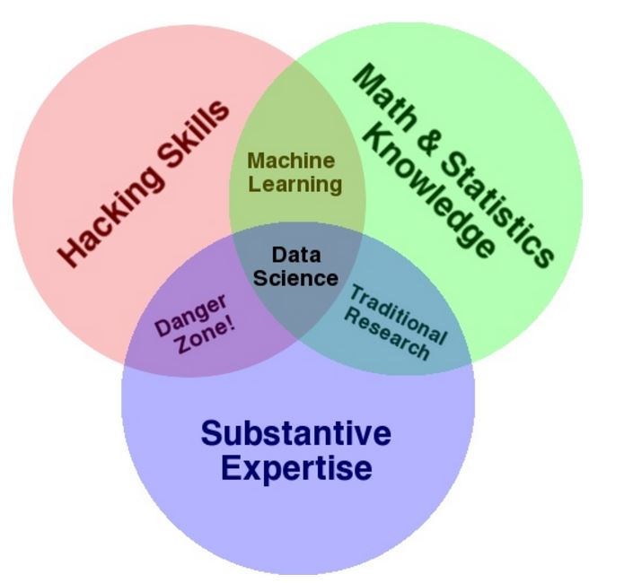

What is data science?

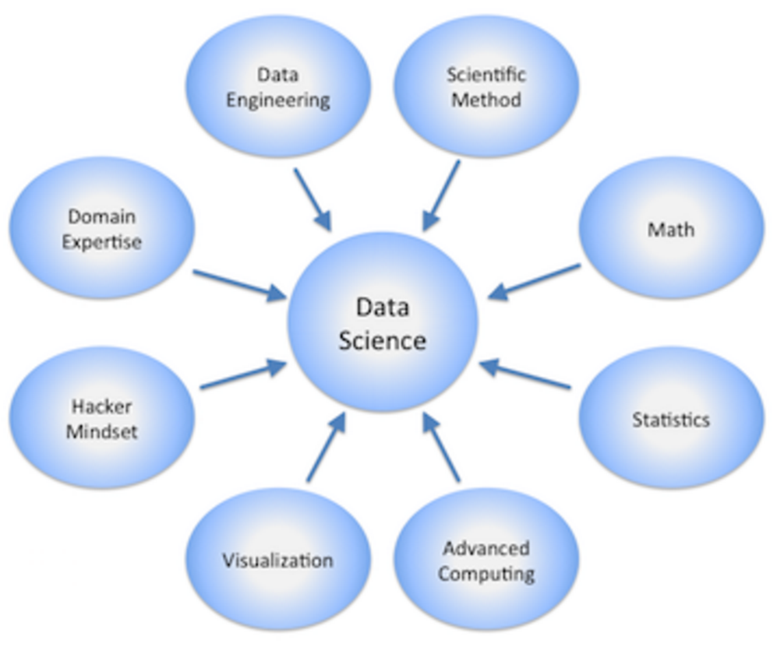

Data scientist

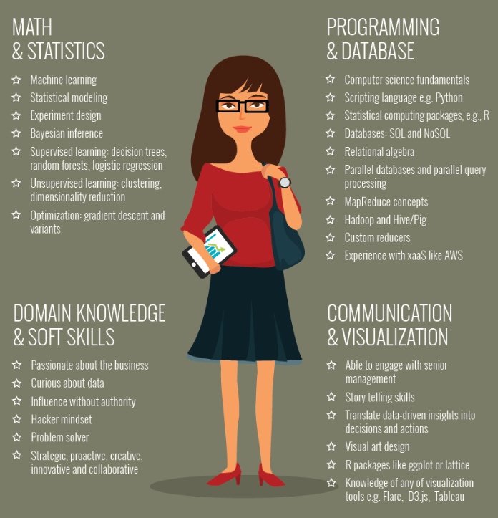

Glassdoor best job in 2016 - 2017

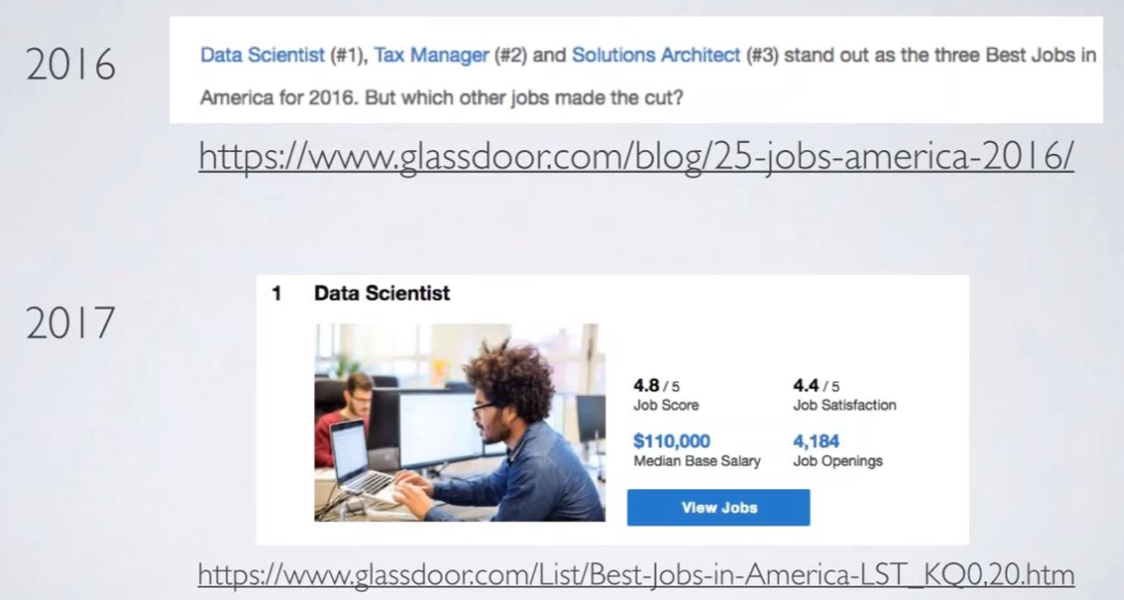

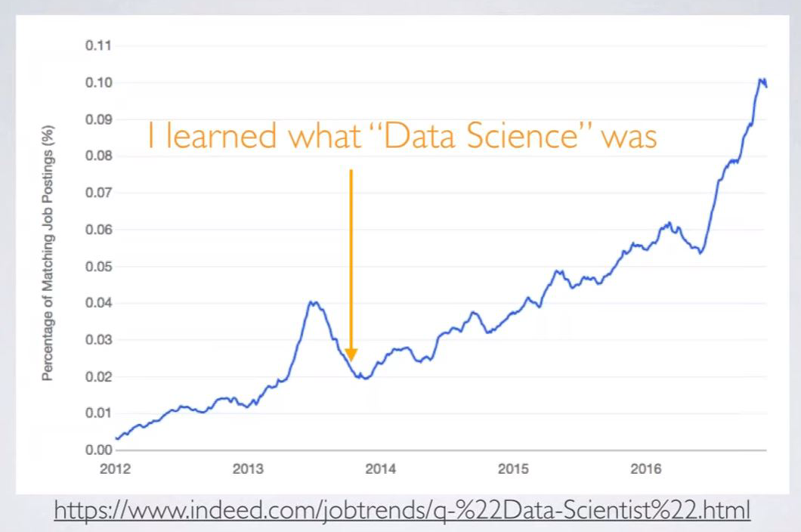Data science job trend

Data science job

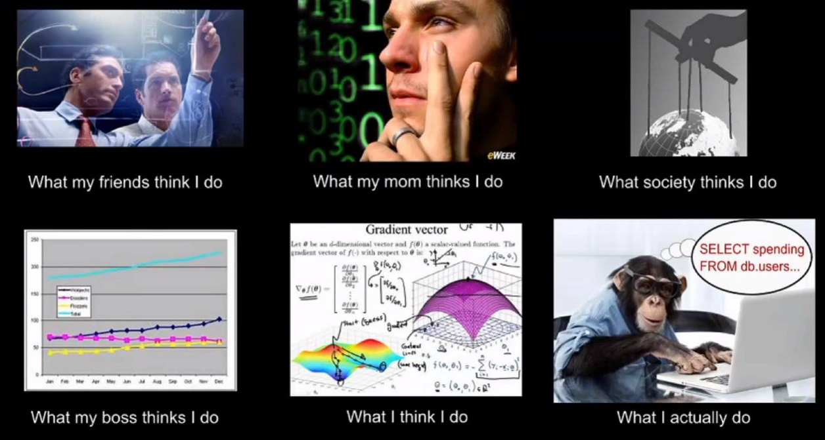

Data Scientist education levels

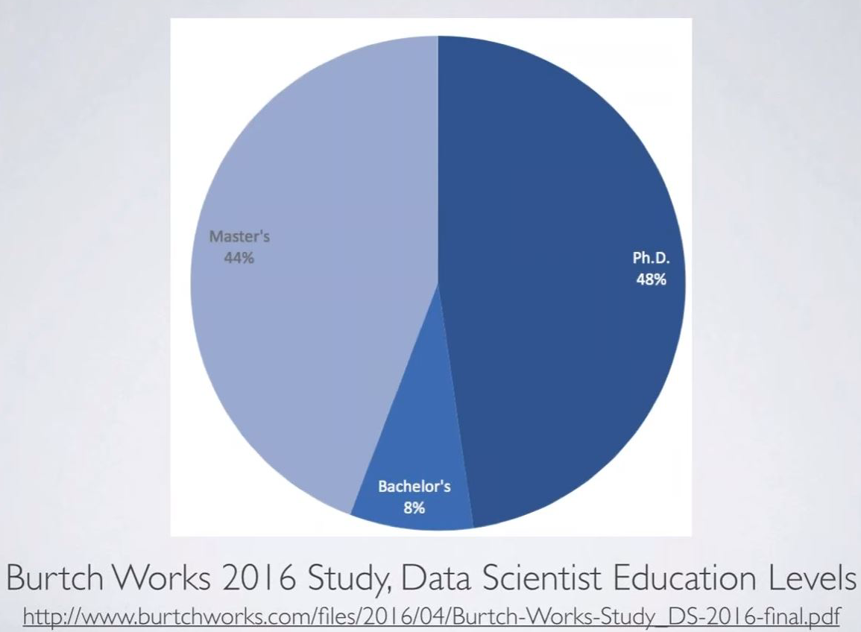

Data science backgrounds

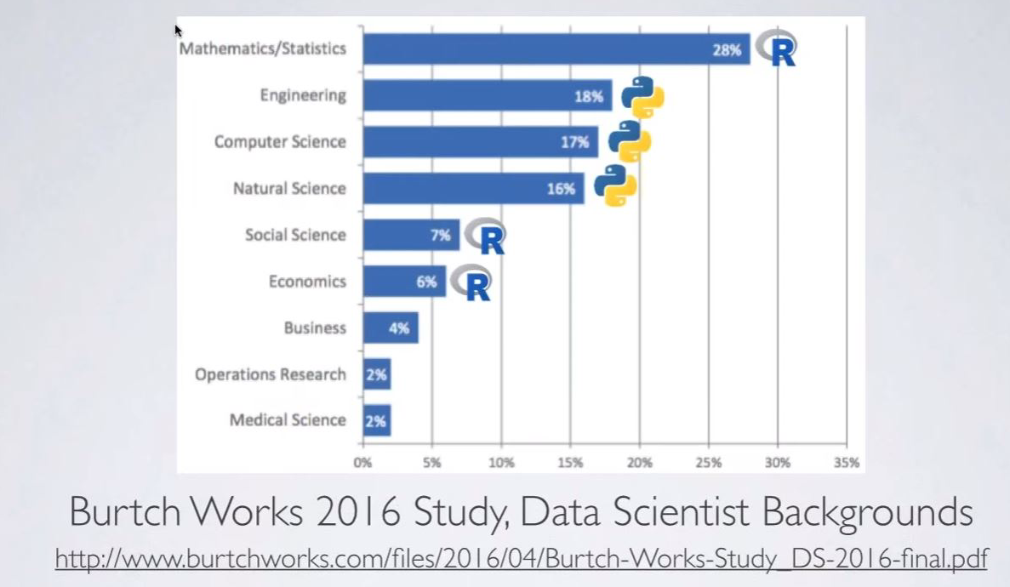

Key topic to learn

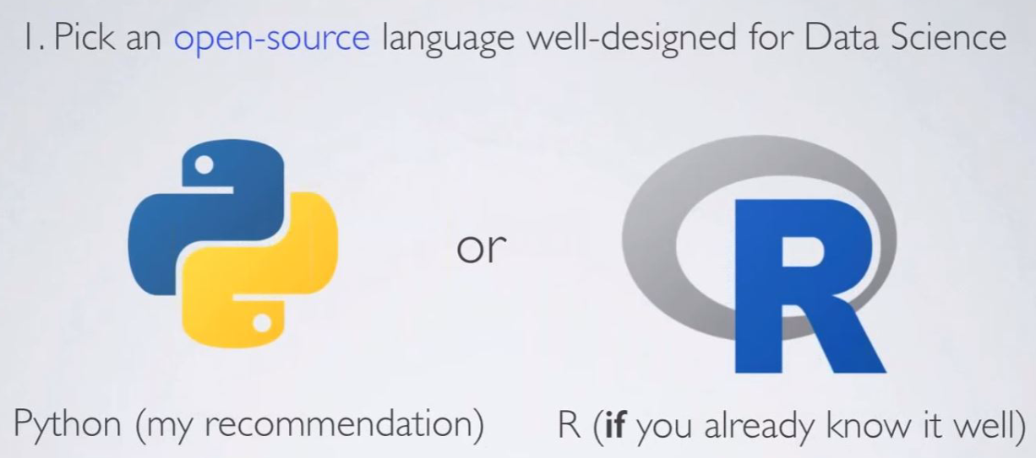

Learn Python library stack

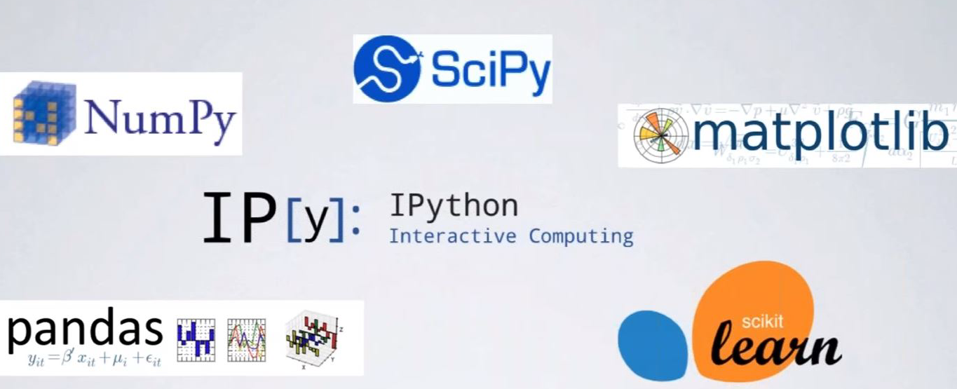

Go kaggle

* There are countless strategies that can be applied to any predictive modelling
* It is impossible to know at the outset which technique or analyst will be most effective
* Compete to produce the best models

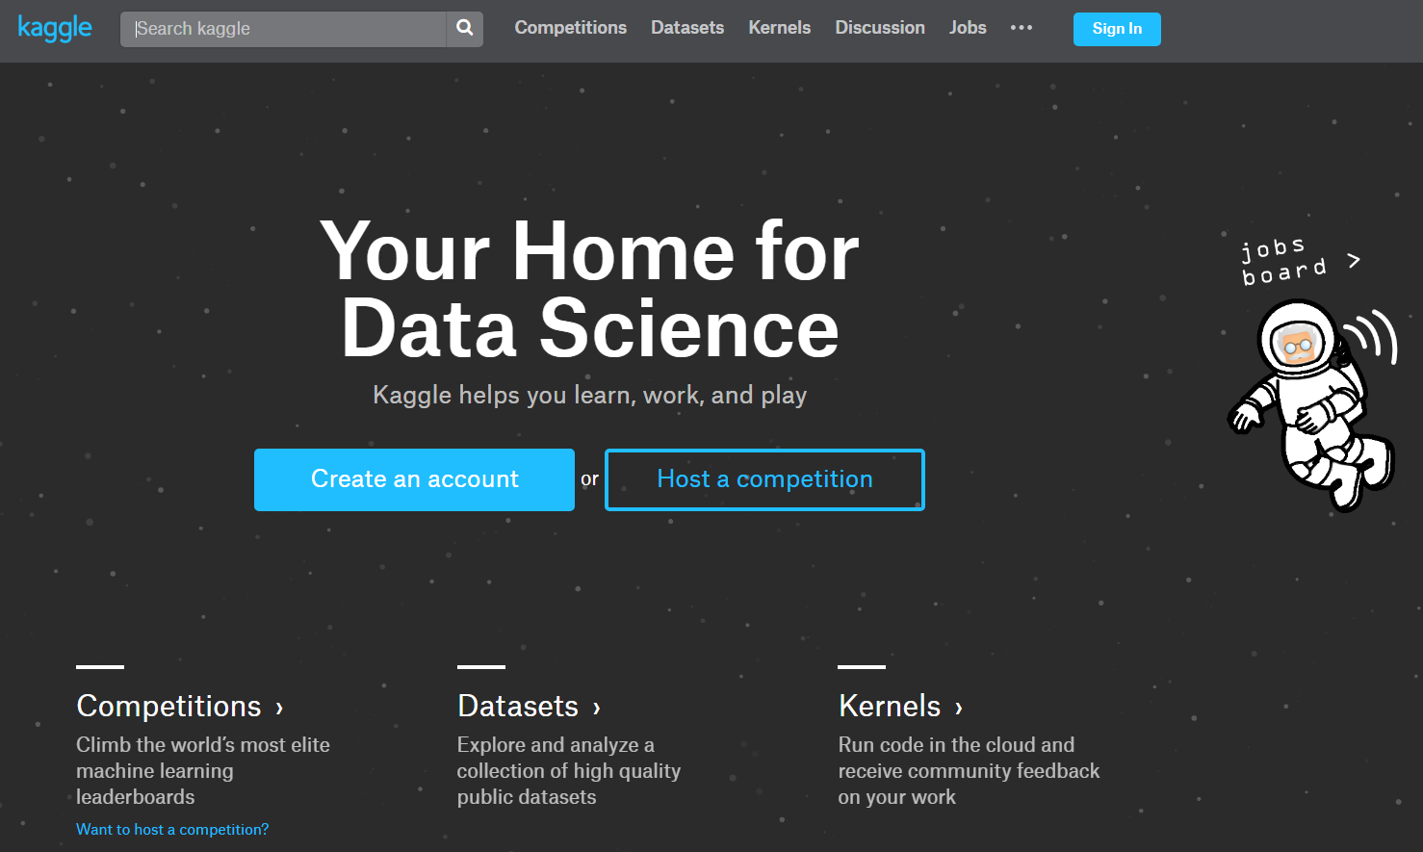

Get your degree

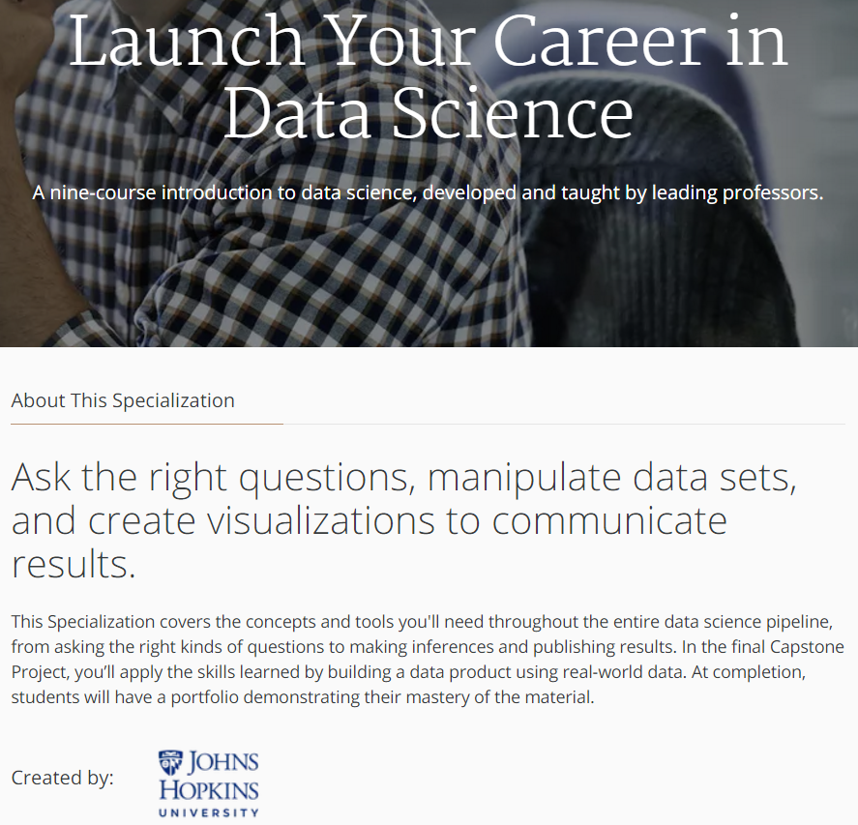

**Johns Hopkins University** (commonly referred to as **Johns Hopkins**, **JHU**, or simply **Hopkins**) is an American [private](https://en.wikipedia.org/wiki/Private_university) [research university](https://en.wikipedia.org/wiki/University) in [Baltimore, Maryland](https://en.wikipedia.org/wiki/Baltimore). Founded in 1876,

Investigate the teams

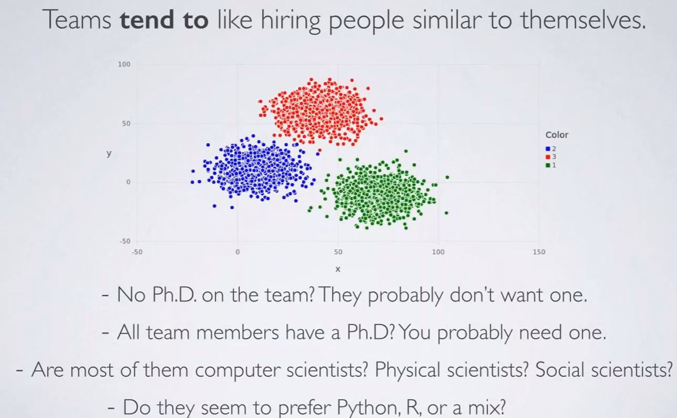

Interview question type

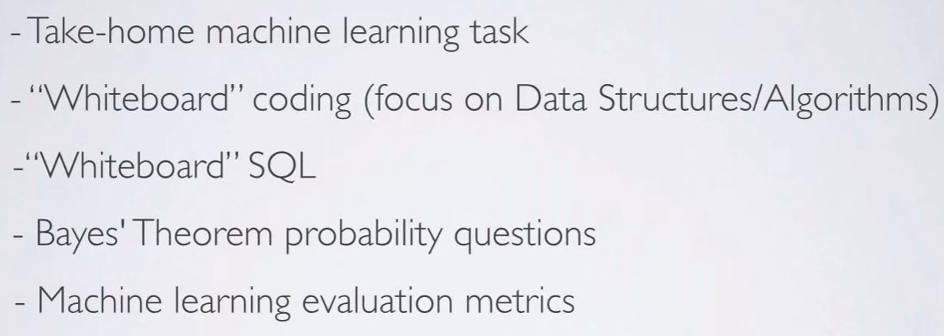

Take-home machine learning task

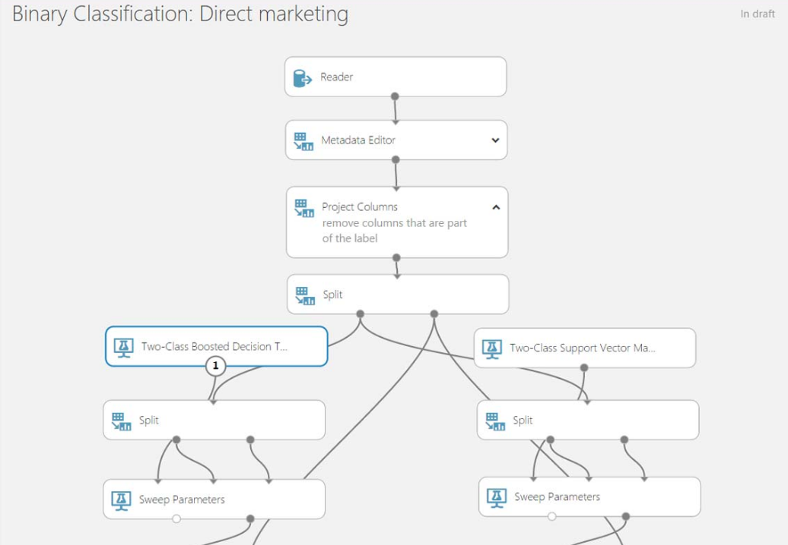

Whiteboard coding

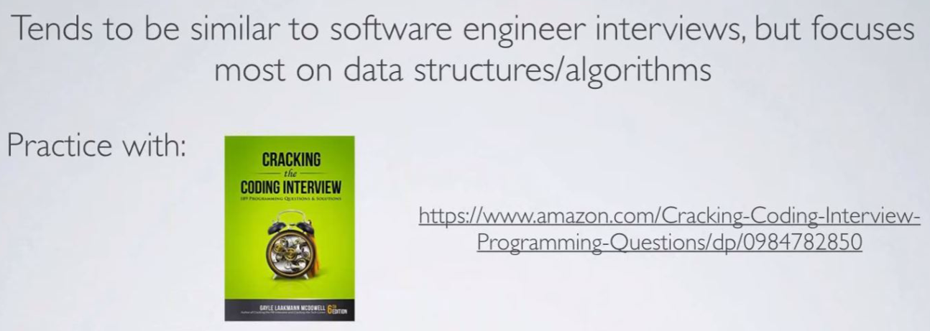

Whiteboard SQL

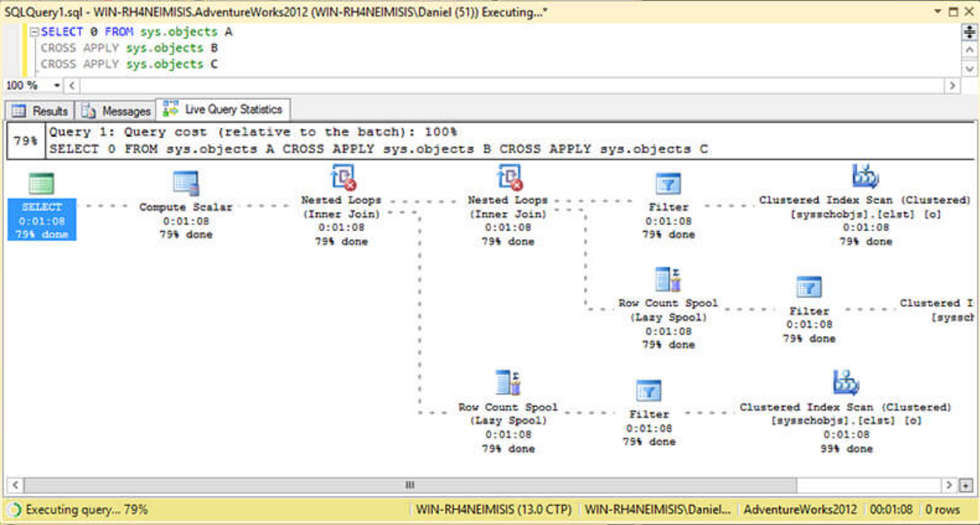

Bayes’ theorem

* Memorize this formula

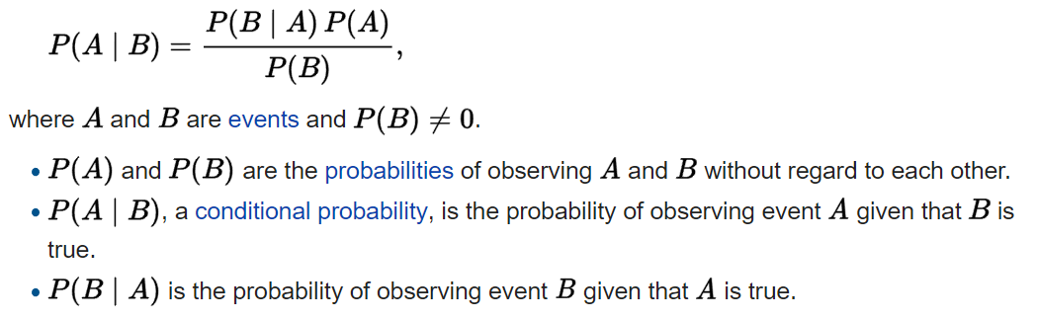

* Understand terms
* Bayes’ theorem describes the probability of an event
* based on prior knowledge of conditions that might be related to the event
* For example, if cancer is related to age, age should be included as input parameter

Machine learning evaluation metrics

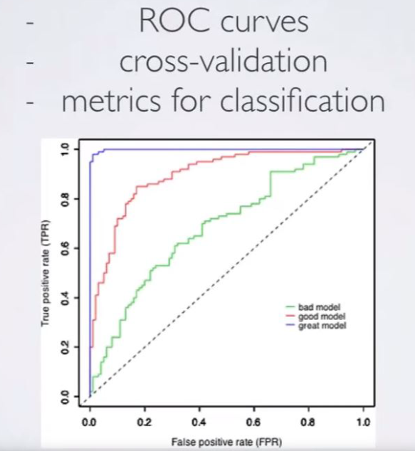

Data Science job fact #1

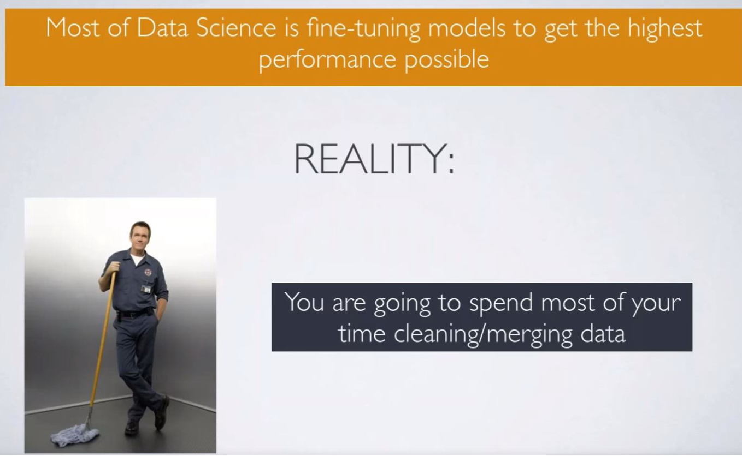

Data Science job fact #2

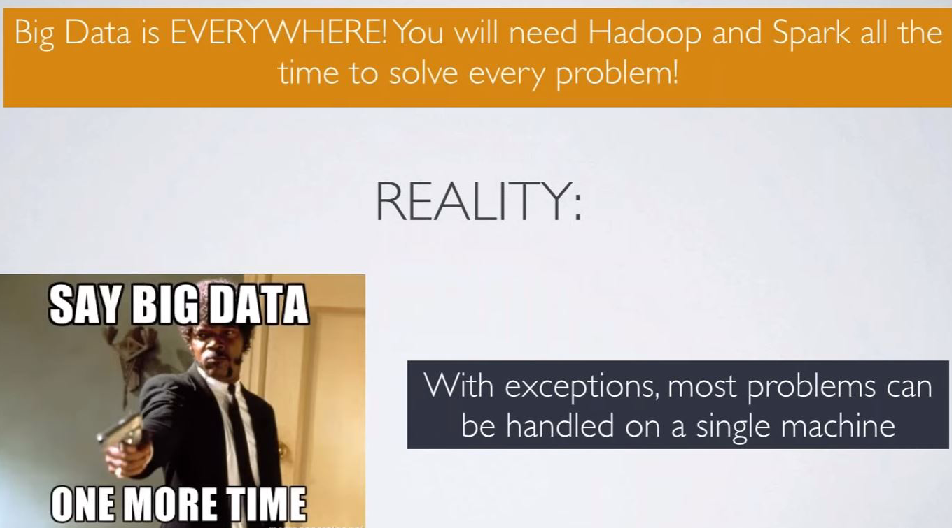

Data Science job fact #3

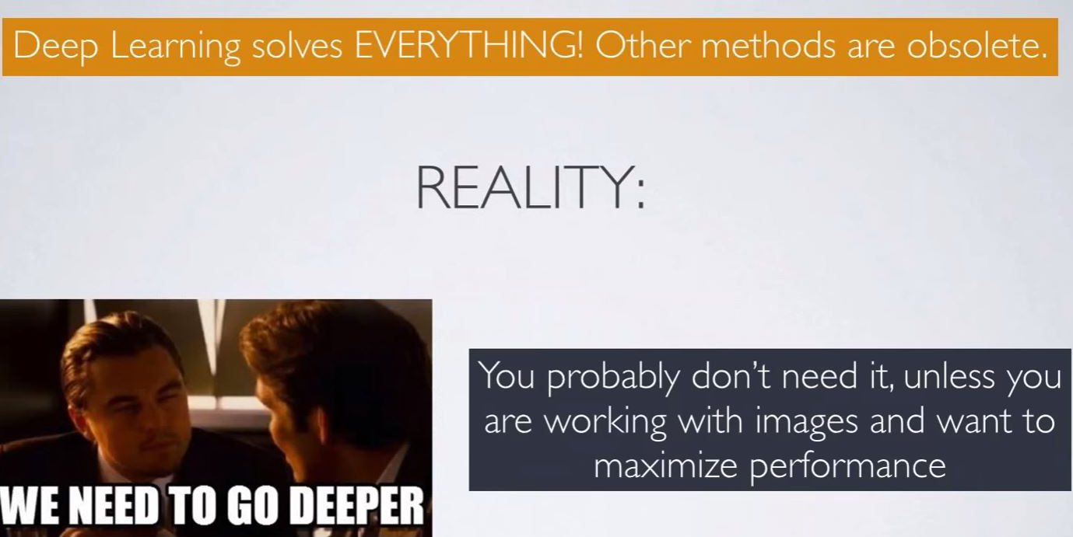

DS compared to ML engineer

How is a Machine Learning Engineer

different form a Data Scientist?

ML Engineer

Data Scientist

* Trained to be strong in Coding
* C++, Java, C#
* Coding
* Change algorithm to code
* Create ML module
* Trained to be strong in Data
* R, Python, MATLAB
* Data treatment
* Evaluate ML algorithm
* Evaluate ML module

More information

**More information on Data Science**

Doing Data Science by Cathy O'Neil, Rachel Schutt: Chapter 1. Introduction: What Is Data Science?

https://www.safaribooksonline.com/library/view/doing-data-science/9781449363871/ch01.html